Profile for Youth, Children and Families Worker

Clifton Diocese

Our Diocese covers the City and County of Bristol as well as the counties of Gloucestershire, Somerset and Wiltshire. Our Diocesan vision A Future Full of Hope emphasises a ‘more outward focus’ inspired by Pope Francis. The vision document can be downloaded from the Diocesan website, cliftondiocese.com. The creation of this role is inspired by this Diocesan vision which would guide all of the work undertaken. Our Diocesan youth service offers a range of training, support and events. Part of the role involves facilitating access to these Diocesan resources for our young people and volunteers as well as making use of training and resources for themselves.

Parishes

Our parishes of St Francis, Nailsea and St Joseph, Portishead comprise two churches, with one in each town. Both towns are situated about 10 miles from the centre of Bristol and a number of our parishioners commute to work in Bristol. Nailsea had a population of 15,630 at the last census, while Portishead has a population of 25,000. The parishes also encompass a number of villages, with the largest of these being Backwell (population 4589) and Pill/Easton-in-Gordano (population about 7000).

Our average Sunday Mass attendance is 212 in Nailsea and 189 in Portishead.

St Joseph, Portishead

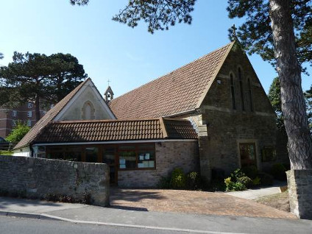

The mission was founded by French Franciscans (OFM) who had settled at Bristol. In July 1883 two houses (Claremont and Belle Vue) on West Hill, Portishead, were acquired. A temporary chapel was built in one of their gardens. The foundation stone for the present church was laid on 16 November 1886 by the Very Rev. Chrysostom, the Provincial of the Franciscan Friars. It was designed by the architect-priest the Rev. (from 1893 Canon) A. J. C. Scoles, who had also designed the contemporary Franciscan church at Clevedon. The church was opened and dedicated by Bishop Clifford on 19 March 1887. The following year, the friars moved to Clevedon from where they continued to serve the Portishead mission until 1906. In 1907, two friars and a lay brother from the Conventual Franciscans came to Portishead, and the Conventuals continued to have pastoral care for the parish until 1985, when the first Diocesan parish priest, Canon O’Callaghan came to the parish.

St Francis, Nailsea

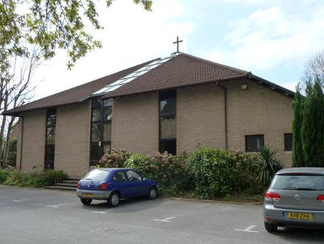

In 1937, the Franciscans of Clevedon founded a permanent Mass Centre at Nailsea. In the 1950s they purchased a site for a church and built a temporary building. In 1979, the parish school was built and Mass was said in the school hall. In September 1982, the parish was erected and the Bishop’s secretary, Fr (Mgr) Leyden, appointed as the first parish priest.
The present church was built in 1985-86 as part of a design and build contract with Stone and Co. Ltd, who commissioned designs from the architect John Webster of Holford Associates. It was blessed and opened on 2 February 1986 by Bishop Alexander. In 2000, a matching hall was built beside the church and presbytery.

The parishes today

Since the beginning of 2013, the parishes have been working much more closely together with a shared parish priest, Fr Tom Dubois. Whilst retaining their own distinct identity and mission, the parishes collaborate in a number of joint projects and programmes, such as our confirmation programme. The vision teams in both parishes meet together regularly to pray and engage in strategic planning.

Both parishes have a very strong commitment from volunteers including parishioners as well as non-Catholics and give generously of their time and talents in building the life of the parish. We employ two part-time administrators, Elaine Shiel in Nailsea and Norma Hayden in Portishead who each work two mornings a week. We also employ a part-time cleaner for the hall in Portishead, Sharon Read, who works two hours a week.

Both parishes are blessed by the ministry of deacons, with Rev Paul Reddington and Rev Ivan Reynolds primarily serving St Francis, Nailsea and Rev Didier Delaplace primarily based at St Joseph, Portishead.

We have inherited a strong spiritual legacy from the Franciscans who first ministered here. A number of parishioners belong to the Franciscan Third Order. We have a number of different prayer groups in a variety of styles. Two years ago, we began having perpetual Eucharistic adoration in the parishes. Each parish has two days and one night of adoration each week, which has had a big spiritual impact.

The parishes have a strong commitment to ongoing formation, offering a variety of programmes and small groups as well as access to Diocesan formation opportunities.

Encouraged by the Diocesan Year of Mission, we have increased the opportunities for people to deepen, discover or rediscover faith, with both parishes offering the ChristLife programme. Come Home for Christmas is our main outreach to resting Catholics who are invited to take part in the Landings programme.

Our parishes are involved in a wide range of outreach activities within our local community and the wider world including the Julian Trust night shelter, Christians Against Poverty, Foodbank, Wellspring Counselling and supporting Syrian refugees. Each year we choose two parish charitable projects suggested by parishioners for which we raise both funds and awareness. We also hold second collections and raise funds for a number of other charities and projects including CAFOD, Missio and Clifton Children’s Society.
Our ministry to children, young people and families has been identified as a key strategic focus, leading to the creation of this role. We have recently established ‘Wings’ in Portishead to support pre-school children and families. In Nailsea, That Man is You is a programme for men that we run every Wednesday from 6-7.30am, with breakfast, input, discussion
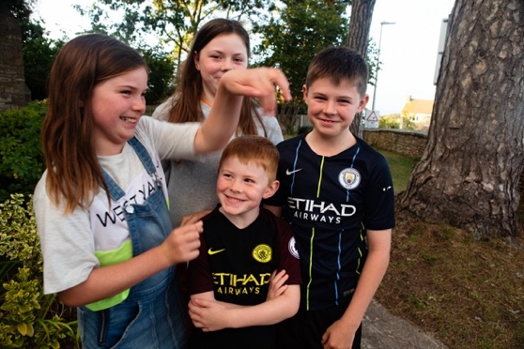
and prayer to support men in their marriages and family life. In Portishead the UCM provides a forum for supporting grandmothers. In Nailsea we have a regular Ladies Circle providing informal support to women.

Schools

We have two parish primary schools, with one in Nailsea and the other in Portishead. Both are single form entry schools with a strong Catholic ethos. Part of the role involves building and strengthening the existing links between the schools and parish.

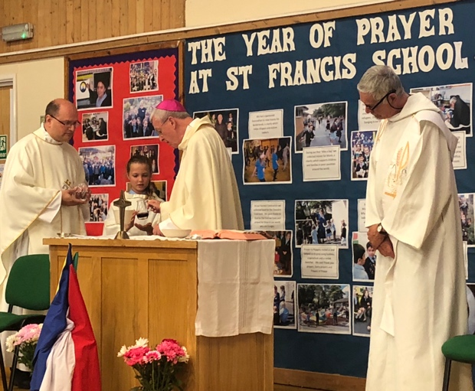

Ecumenical links

We maintain excellent links with other local Christians. Formally we are part of four Churches Together/Christians Together areas, in Pill, Portishead, Nailsea and Backwell. Other Christian groups within these partnerships employ youth, children and/or family workers and there is considerable scope for working in partnership with them on particular projects.

Facilities for Youth, Children and Family Worker role

We will provide office space in both Nailsea and Portishead. We also have a number of excellent facilities that you will be able to use including small meeting rooms and much larger halls.

Support for the role

The line manager for this position is the parish priest of the two parishes, who is fully supportive of the project and will meet with you weekly.

We recognise the importance of having a really good support structure in place within the parishes, and to this end have created a support group who will meet with you every couple of months to provide informal support.

There is a support group for Christian youth workers in Nailsea that you will be able to take part in.

Our Diocesan Youth Ministry offers support, advice, resources and training that you will also be able to access.

